Adequate parking lot illumination is an investment that will bolster security and safety considerations within your organization while simultaneously improving the visibility of your enterprise at night to increase general awareness to those who may otherwise be unaware of your establishment. National LED recently partnered with Gay Family Kia in Dickinson, TX to accomplish all these items and much, much more. Gay Family Kia was looking to expand the footprint of their dealership to increase their inventory capabilities to better serve their customers. With additional real estate, on-premises capable of serving expansion efforts, and an existing parking area that was historically utilized for overflow/ employee parking; the friendly folks at Gay family Kia found themselves at an end pass.
-Enter National LED.
This project began with a site visit to discuss the vision of what exactly Gay family Kia aimed to accomplish, lessons learned from previous projects, and pitfalls they aimed to avoid. This positioned National LED to come in on-time, under budget, and exceeding our customers’ expectations in every capacity.
The scope of this project required adding breakers in existing service panels of 2 different building locations, sawing 1,000’+ of concrete, running power to 10 new pole locations, followed by burying/ pouring fresh concrete to cover the new power supply and additionally, pour the foundation for these 10 new light pole locations. Lastly, Gay family Kia wanted a fresh-looking parking lot to complement their vastly improved lighting, so in addition to the scope of services detailed above, the last item on the docket was resurfacing this area with new asphalt.
While a project of this scope and complexity might traditionally be limited to the scope of a General Contractor, and a plethora of sub-contractors (and their subsequent price mark-up); this is where National LED is uniquely aligned to best serve its clientele through unparalleled quality of work & LED fixtures, world class project managers that are always but a phone call away, and the friendly customer service provided by our staff that speaks for itself. Click Here to See National LED Reviews

Construction kicked off at Gay Family Kia in spring of 2021 with marking/ measurement duties to indicate the locations requiring concrete sawing/ trenching functions required for new electrical to be installed.
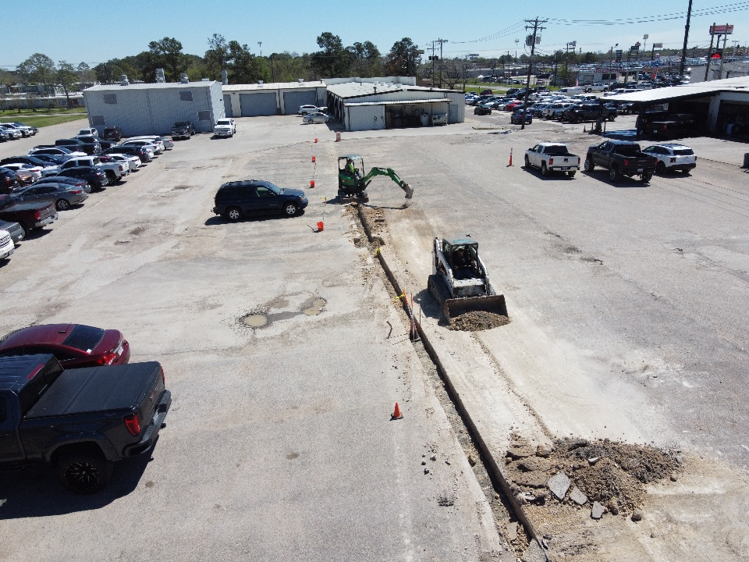
Fig. 1: (Post Concrete-sawing, trenching)
(130) Drilling holes for parking lot poles - YouTube

(130) Cutting concrete - YouTube

Once concrete sawing/ trenching operations were completed, and new electrical was connected to the existing power supply the trench was covered and filled with concrete. At this point, we’re ready for concrete pole foundation forming & anchor bolt mounting.
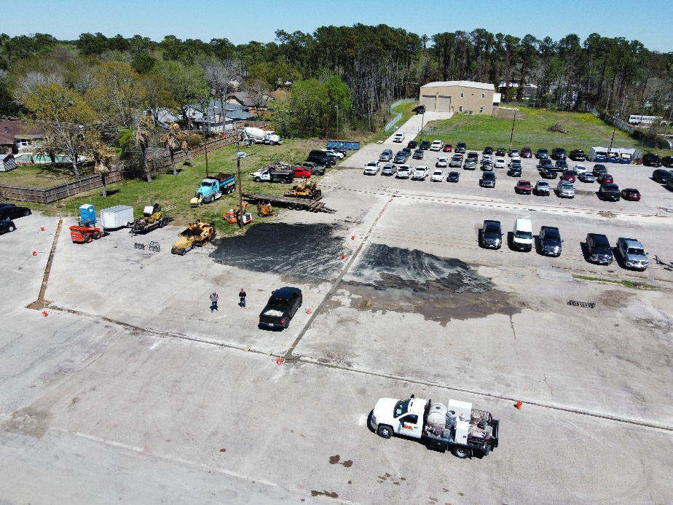
Fig. 2- (New power run from circuit breakers + buried.)

Once the concrete bases have cured the poles are ready to be erected, mounted, and wired into each pole’s power feed.
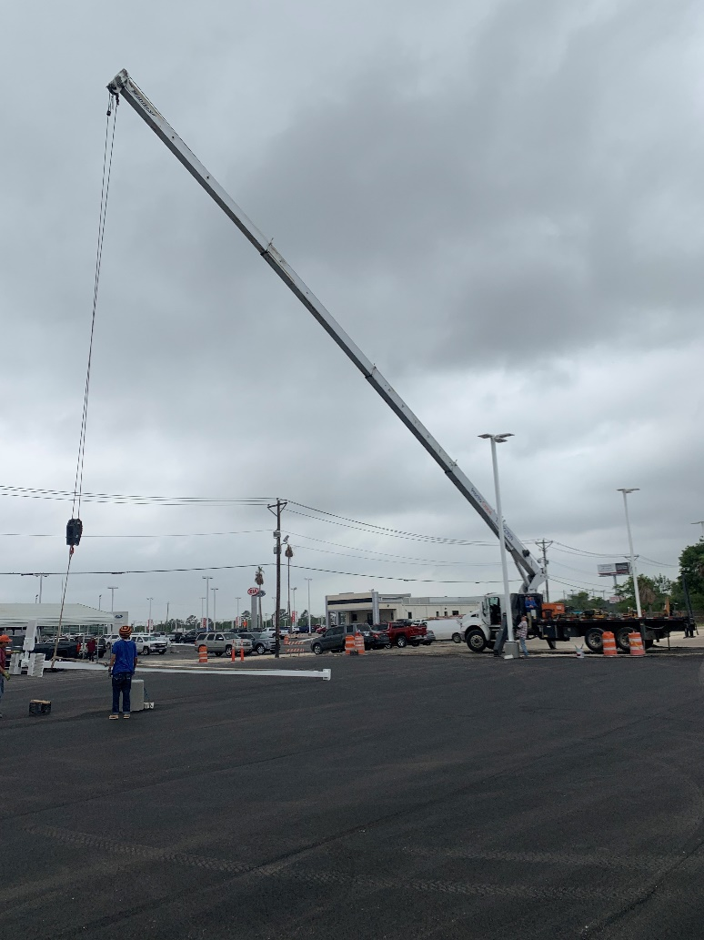
Fig. 4 Pole Erection- 1

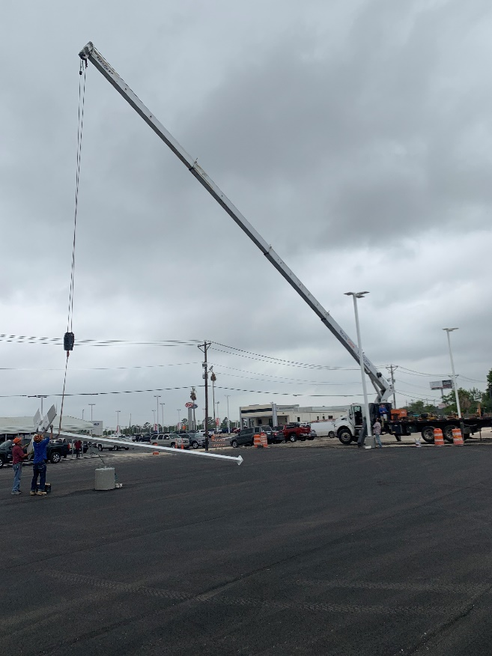
Fig. 5 Pole Erection-2

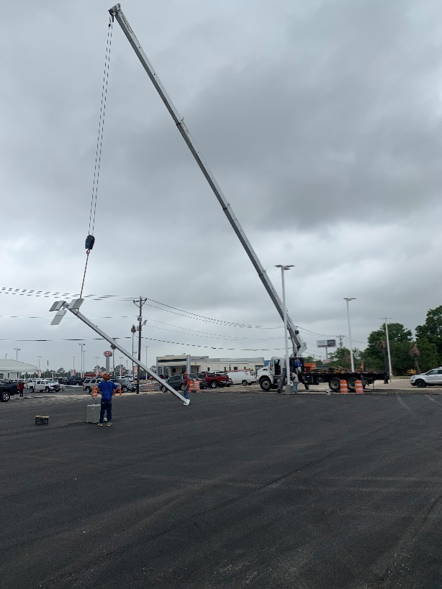
Fig. 6 Pole Erection 3
Once each pole is securely fastened to the anchor bolt patter of each concrete base and adequately connected to power supply the only thing left to do is wait for the sun to set in order to indulge in the complete satisfaction that newly installed LED technology, alone, can provide

SUMMARY
This project was completed on time, on-budget, and in a fashion that exceeded the expectations of the folks at Gay Family Kia and ultimately resulting in an enhanced & wildly improved customer experience they can extend to their valued customers. Throughout the duration of this project Gay Family Kia realized a 0 sum time loss of their sales/ service operations during construction efforts and additionally incurred a 0 sum time loss resulting from accidents/ safety incidents. The successful outcome of these two items are tantamount to the ultimate success of any project, and at National LED; are considered the standard operating procedure. Our dedicated project management staff will partner with your organization to serve as the primary point of contact through out the duration of any project, large or small, every step of the way. This alignment has and continues to prove to be valuable to our clientele as it allows them to focus their time and energy on their core competencies, and offload all facets of project management/ execution to the lighting experts at National LED. This commitment and dedication to maintaining an open dialogue with our clients through out all phases of construction has earned National LED the reputation of an industry leader in the commercial LED space, and affords our clientele a uniquely positive and rewarding experience. Call today and ask how National LED can help with your next parking lot project!

